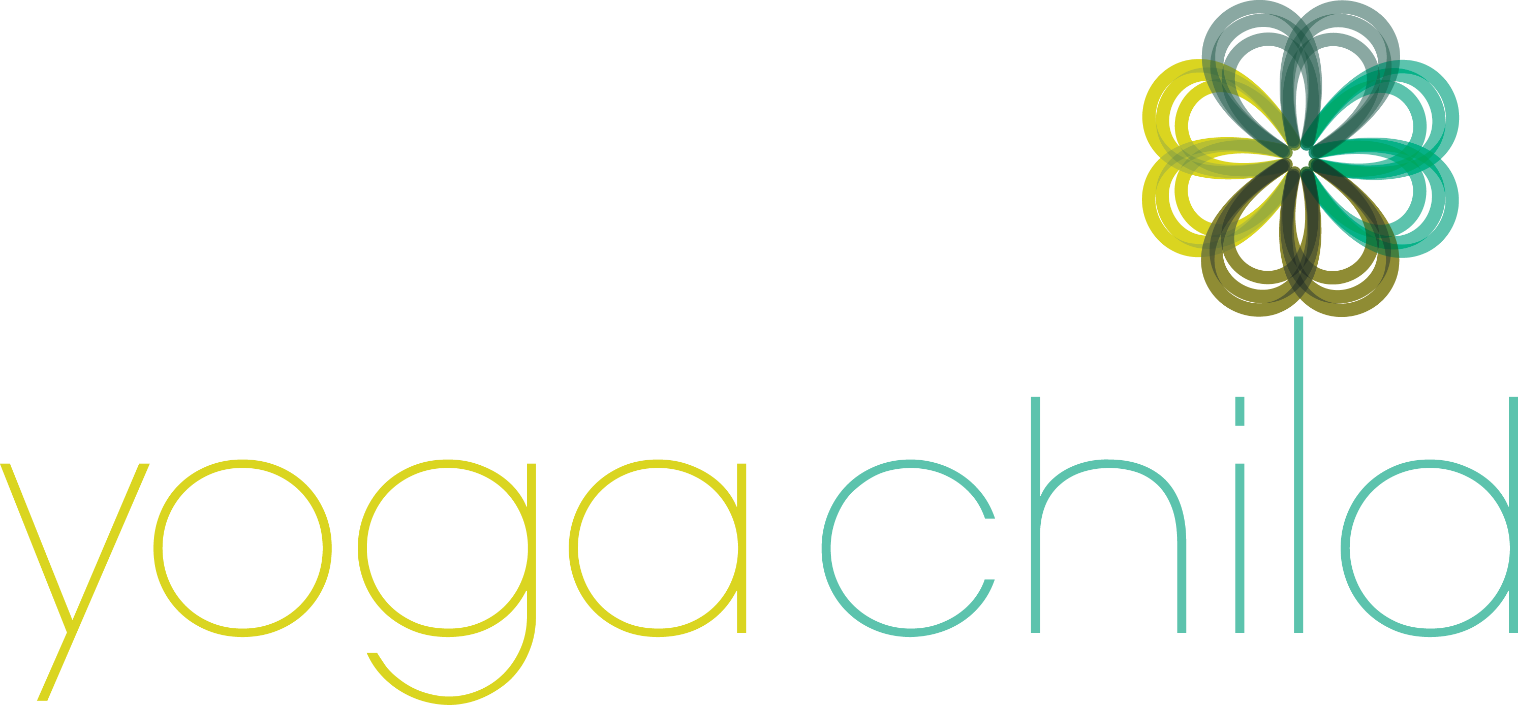
Yoga and Mindfulness for Children, Training & support for schools

Registration Form for Yoga Child Teacher Training, Level I, 50+hr
Teaching Yoga & Mindfulness To Children, Pre-school – Grade 5

Name:
Address:
Phone Number:
Email/Website:
Emergency Contact:
Name: Relation:
Phone Number:
Training Start Date:
Location of Training:
Payment Method: (Checks only for trainings at The Yoga Garden please)
Check: Amount______________ Check number__________
Please check the applicable boxes:
☐ I have enclosed payment in full plus the non-refundable $50 registration fee the amount of: ________
☐ I have enclosed a non-refundable 10% deposit plus the non-refundable $50 registration fee in the amount of: _________
☐ I have already paid my non-refundable $50 registration fee on line through the Yoga Garden website.
☐ I have registered in time to take advantage of the early bird discount and therefore the total amount due will be discounted by $100 and have adjusted my payment above accordingly.
Deposits and registration fees are non-refundable. Balances are due prior to the start of training.
Please return via mail or to: info@yogagardennarberth.com
The Yoga Garden
131 N. Narberth Ave
Narberth PA 19072 ☐ I’m ready to become a children’s yoga teacher - Namaste

